Day 1 : List of Programs
Q1. The intervals and corresponding frequencies are as follows. age frequency
1-5. 200
5-15 450
15-20 300
20-50 1500
50-80 700
80-110 44
Compute an approximate median value for the data
Input:
#age, frequency
age<-c(5,15,20,50,80,110)
frequency<-c(200,450,300,1500,700,44)
median(age)
median(frequency)
Output:
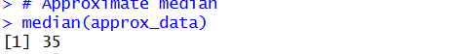

Q2. Suppose that the data for analysis includes the attribute age. The age values for the data tuples are (in increasing
order) 13, 15, 16, 16, 19, 20, 20, 21, 22, 22, 25, 25, 25, 25, 30, 33, 33, 35, 35, 35, 35, 36, 40, 45, 46, 52, 70.
(a) What is the mean of the data? What is the median?
(b) What is the mode of the data? Comment on the data’s modality (i.e., bimodal, trimodal, etc.).
(c) What is the midrange of the data?
(d) Can you find (roughly) the first quartile (Q1) and the third quartile (Q3) of the data?
Input:
#mean,median,mode,quatile
age<-c(13,15,16,16,19,20,20,21,22,22,25,25,25,25,30,33,33,35,35,35,35,36,40,45,46,52,70)
mean(age)
median(age)
mode_age<-names(table(age))[table(age)==max(table(age))]
mode_age
range(age)
quantile(age,.25)
quantile(age,.75)
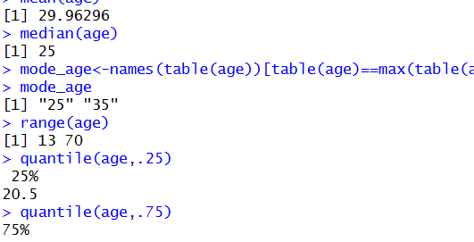

Given data (already sorted)
13, 15, 16, 16, 19, 20, 20, 21, 22, 22,
25, 25, 25, 25, 30, 33, 33, 35, 35, 35,
35, 36, 40, 45, 46, 52, 70
Number of observations
n=27

(a) Mean and Median
Mean
Sum of all values=809 Mean=809/27≈29.96 (≈30)
Median
Since n=27,
Median position=(n+1)/2=14
14th value = 25
✅ Mean ≈ 29.96
✅ Median = 25

(b) Mode and Modality
Frequency highlights:
• 25 appears 4 times
• 35 appears 4 times
Both are the highest frequencies.
✅ Modes = 25 and 35
✅ Modality = Bimodal
(c) Midrange
Midrange=(Min+Max)/2= (13+70)/2=41.5
✅ Midrange = 41.5
(d) First Quartile (Q1) and Third Quartile (Q3)
Quartile positions:
Q1=(n+1)/4=7th value
Q3=3(n+1)/4=21st value
• 7th value = 20
• 21st value = 35
✅ Q1 ≈ 20
✅ Q3 ≈ 35

✅ Final Summary
Measure Value
Mean ≈ 29.96
Median 25
Mode 25, 35
Modality Bimodal
Midrange 41.5
Q1 ≈ 20
Q3 ≈ 35

Q3. Normalization (Reduction & Transformation)
Use the two methods below to normalize the following group of data: 200, 300, 400, 600, 1000
(a) min-max normalization by setting min = 0 and max = 1 (b) z-score normalization
input:
# Data
x <- c(200, 300, 400, 600, 1000)
# (a) Min–max normalization (range 0 to 1)
min_max_norm <- (x - min(x)) / (max(x) - min(x))
min_max_norm
# (b) Z-score normalization
z_score_norm <- (x - mean(x)) / sd(x)
z_score_norm
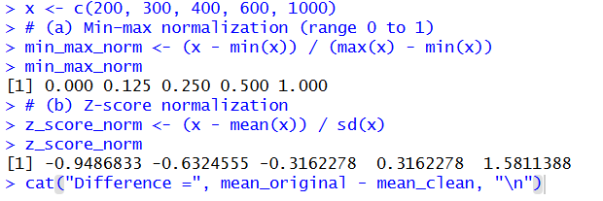

Q4., S mo o t h i n g b y B i n n i n g ( R e d u c t i o n & Tr a n s f o r ma t i o n )
Data: 11,13,13,15,15,16,19,20,20,20,21,21,22,23,24,30,40,45,45,45,71,72,73,75
a) Smoothing by bin mean
b) Smoothing by bin median
c) Smoothing by bin boundaries
input:
data <- c(11,13,13,15,15,16,19,20,20,20,21,21,22,23,24,30,40,45,45,45,71,72,73,75)
bins <- 5
bin_indices <- cut(data, bins)
mean_smooth <- tapply(data, bin_indices, mean)
print(mean_smooth)
median_smooth <- tapply(data, bin_indices, median)
median_smooth
min_max_smooth <- tapply(data, bin_indices,
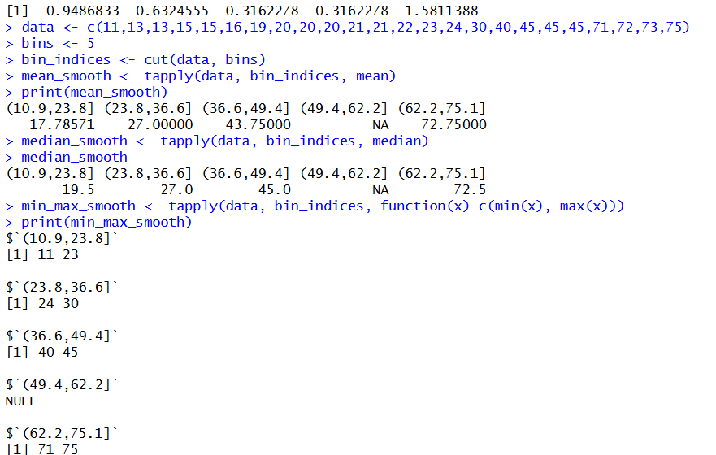

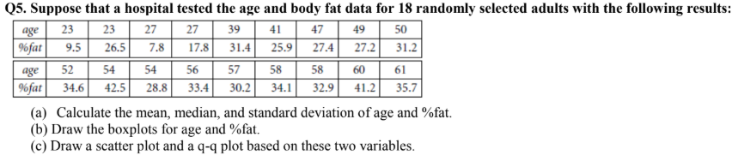
Input:
age<-c(23,23,27,27,39,41,47,49,50,52,54,54,56,57,58,58,60,61)
fat<-c(9.5,26.5,7.8,17.8,31.4,25.9,27.4,27.2,31.2,34.6,42.5,28.8,33.4,30.2,34.1,32.9,41.2,35.7)
mean(age)
median(age)
sd(age)
mean(fat)
median(fat)
sd(fat)
#boxplot
boxplot(age,fat)
#scatter plot
scatter.smooth(age,fat)
#qplot
qqplot(age,fat)
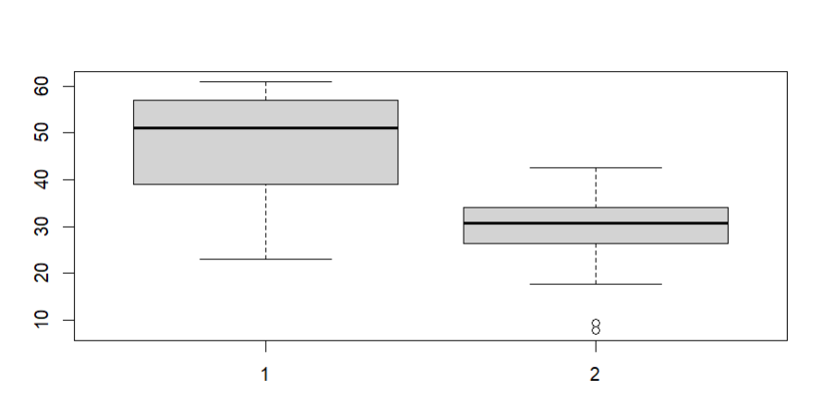\
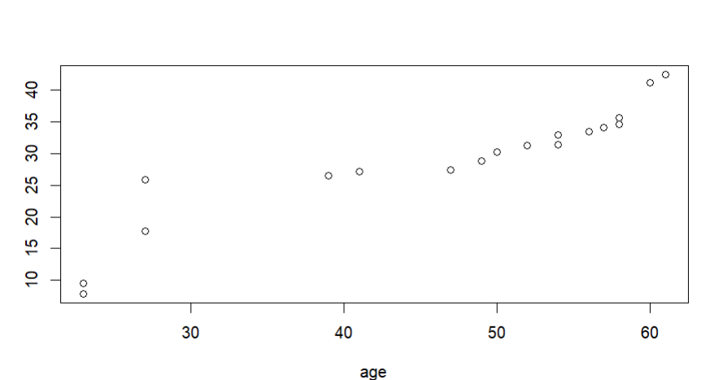
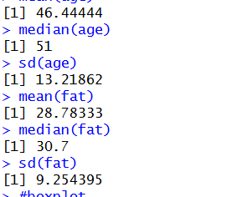

Q6.Suppose that a hospital tested the age and body fat data for 18 randomly selected adults with the following results:
(i) Use min-max normalization to transform the value 35 for age onto the range [0.0, 1.0].
(ii) Use z-score normalization to transform the value 35 for age, where the standard deviation of age is 12.94 years.
(iii) Use normalization by decimal scaling to transform the value 35 for age. Perform the above functions using R – tool
Input:
v<-c(23,23,27,27,39,41,47,49,50,52,54,54,56,57,58,58,60,61)
min<-0
max<-1
#min_max
min_max=((35-min(v))/(max(v)-min(v)))
print(min_max)
#z-score
m=mean(v)
s<-12.94
z_score=(35-m)/s
print(z_score)
#decimal scaling
m<-35
j=max(m)<1
decimal_scaling=m/10^j
print(decimal_scaling)
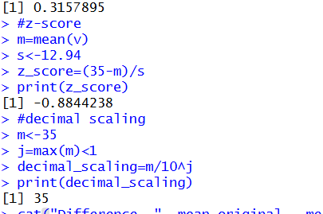

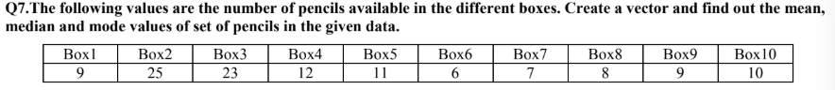
Input:
pencils<-c(9,25,23,12,11,6,7,8,9,10)
mean(pencils)
median(pencils)
mode=names(table(pencils))[table(pencils)==max(table(pencils))]
mode
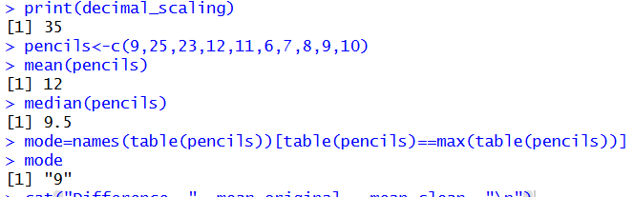
Input:
#scatterplot
x<-c(4,1,5,7,10,2,50,25,90,36)
y<-c(12,5,13,19,31,7,153,72,275,110)
scatter.smooth(x,y)
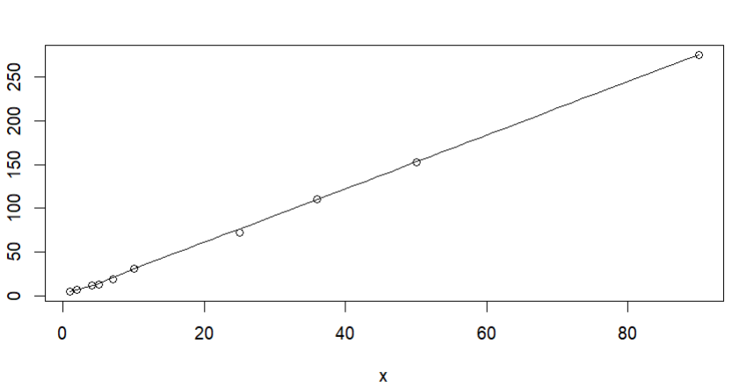
Q9. Implement of the R script using marks scored by a student in his model exam has been sorted as follows: 55, 60, 71,
63, 55, 65, 50, 55,58,59,61,63,65,67,71,72,75. Partition them into three bins by each of the following methods. Plot the data
points using histogram.
(a) equal-frequency (equi-depth) partitioning (b) equal-width partitioning

Input:
marks <- c(55, 60, 71, 63, 55, 65, 50, 55, 58, 59, 61, 63, 65, 67, 71, 72, 75)
num_bins <- 3
bins_eq_frequency <- cut(marks, breaks = num_bins, labels = FALSE)
hist(marks, breaks = num_bins, col = "lightblue", xlab = "Marks", main = "Equal-Frequency
(Equi-Depth) Partitioning")
marks <- c(55, 60, 71, 63, 55, 65, 50, 55, 58, 59, 61, 63, 65, 67, 71, 72, 75)
bin_mean <- tapply(data, cut(data, num_bins), mean)
smoothed_data_by_mean <- unname(bin_mean[as.character(cut(data, num_bins))])
bin_median <- tapply(data, cut(data, num_bins), median)
smoothed_data_by_median <- unname(bin_median[as.character(cut(data, num_bins))])
bin_boundaries <- tapply(data, cut(data, num_bins), function(x) c(min(x), max(x)))
smoothed_data_by_boundaries <- unlist(bin_boundaries[as.character(cut(data, num_bins))])
print("Original data:")
print(data)
print("Smoothed data by bin mean:")
print(smoothed_data_by_mean)
print("Smoothed data by bin median:")
print(smoothed_data_by_median)
print("Smoothed data by bin boundaries:")
print(smoothed_data_by_boundaries)
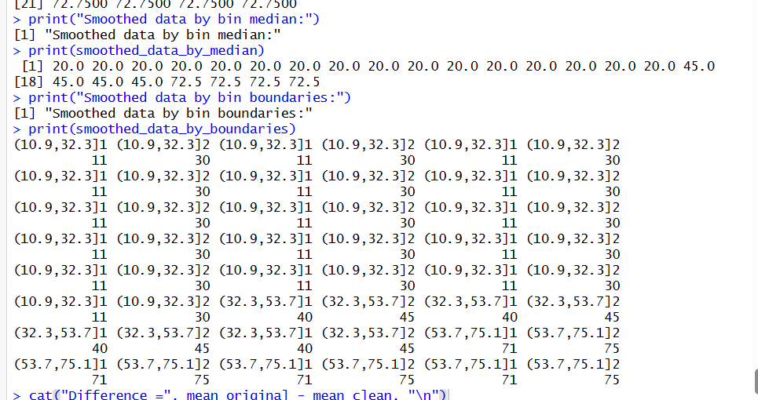
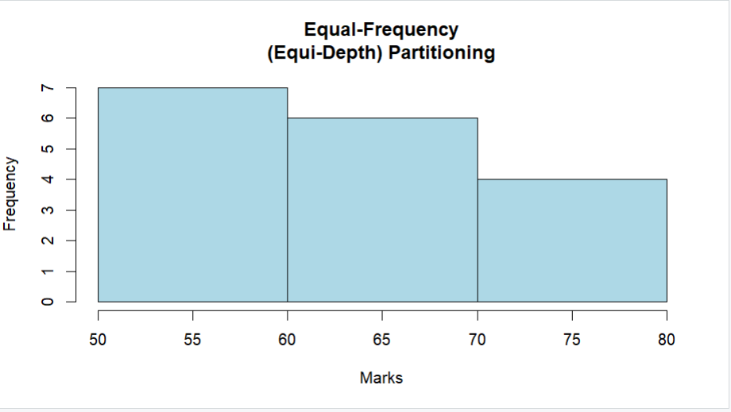

Q10. Suppose that the speed car is mentioned in different driving style.
Regular 78.3 81.8 82 74.2 83.4 84.5 82.9 77.5 80.9 70.6 Speed
Calculate the Inter quantile and standard deviation of the given data.
Input:
#IQR, SD
v<-c(78.3,81.8,82,74.2,83.4,84.5,82.9,77.5,80.9,70.6)
IQR(v)
sd(v)
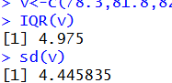

Q11. Suppose that the data for analysis includes the attribute age. The age values for the data tuples are (in increasing order) 13,
15, 16, 16, 19, 20, 20, 21, 22, 22, 25, 25, 25, 25, 30, 33, 33, 35, 35, 35, 35, 36, 40, 45, 46, 52, 70.
Can you find (roughly) the first quartile (Q1) and the third quartile (Q3) of the data
Input:
age<-c(13,15,16,16,19,20,20,21,22,22,25,25,25,25,30,33,33,35,35,35,35,36,40,45,46,52,70)
quantile(age,.25)
quantile(age,.75)
